Kiwanis Club of Hailey and the Wood River Valley
P.O. Box 901
Hailey, ID 83333

Organization: Kiwanis Club of Hailey and the Wood River Valley
Project Title: Balmoral Pavilion
Grant Amount: $10,000.00

1) Objectives & Outcomes: We have installed multiple structures in many of our local parks/playgrounds (see attached photos) over the years. This project was to place a picnic pavilion in Balmoral Park, a fairly new and largely undeveloped park in the south Woodside neighborhood of Hailey. Although this was delayed while the borough pursued additional funding for other aspects of the Park, the pavilion has now been purchased and is expected to be installed this fall through the donated efforts of a local contractor. We also purchased a handicap table for this pavilion (at an additional cost of $765).

2) Impact: This pavilion and park will be used by many hundreds of local children and their families and will provide convenient escape from direct summer sun and the opportunity for picnics and more. In addition to your generous grant, we received some funds from the Little Black Dress Club for this project and our club has raised funds with a food concession at the Rodeo and through recycling aluminum (see photo).

3) Photos: Attached.

4) Budget: While I do not have access to the original proposed budget, we have only spent funds of the equipment itself, with the installation, as mentioned, being donated by a local contractor.

Expenses Amount requested from WRWCF Actual Expenditures

Equipment $10,000.00 $25,570.00

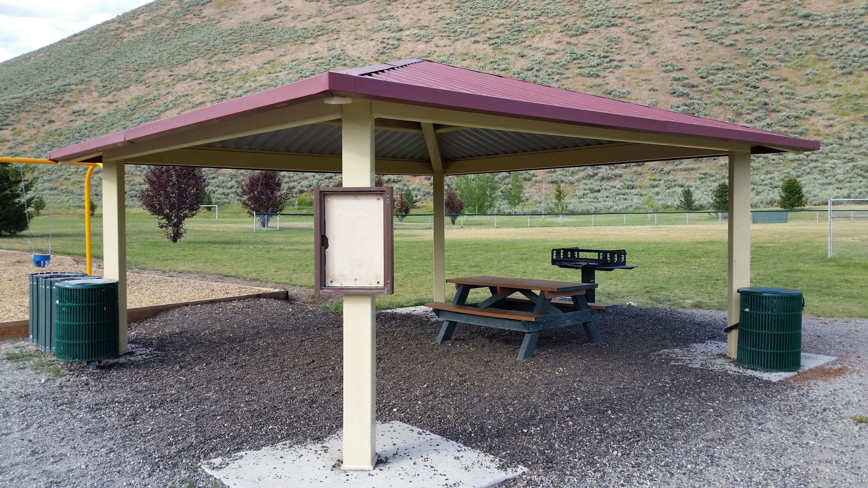

While similar to this pavilion, the Balmoral pavilion is larger, 24’ by 30,’
and the table provided is handicap accessible.

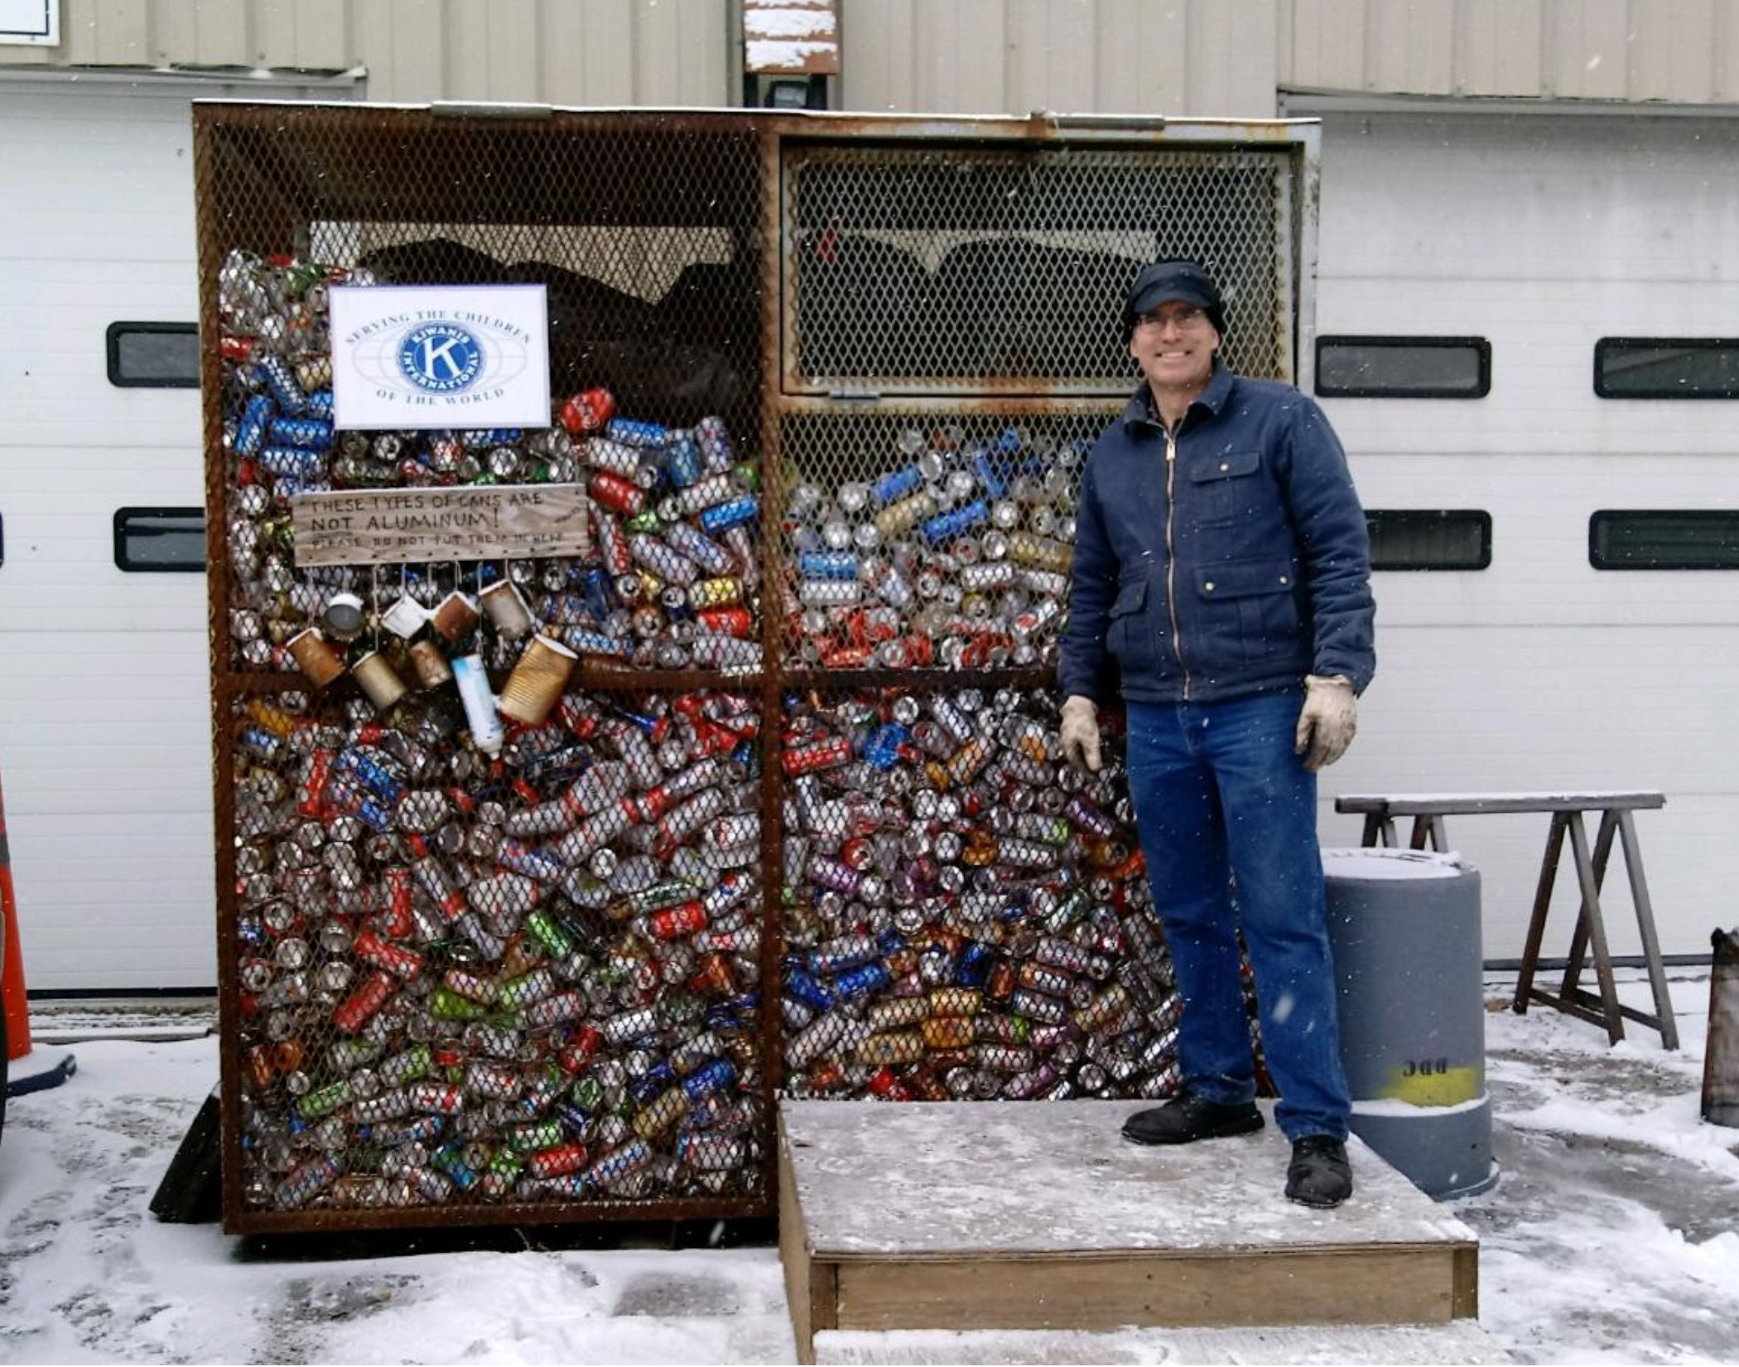

Cans are collected by Bob Wiederrick at
Wiederrick’s Custom Metalworks in South Woodside
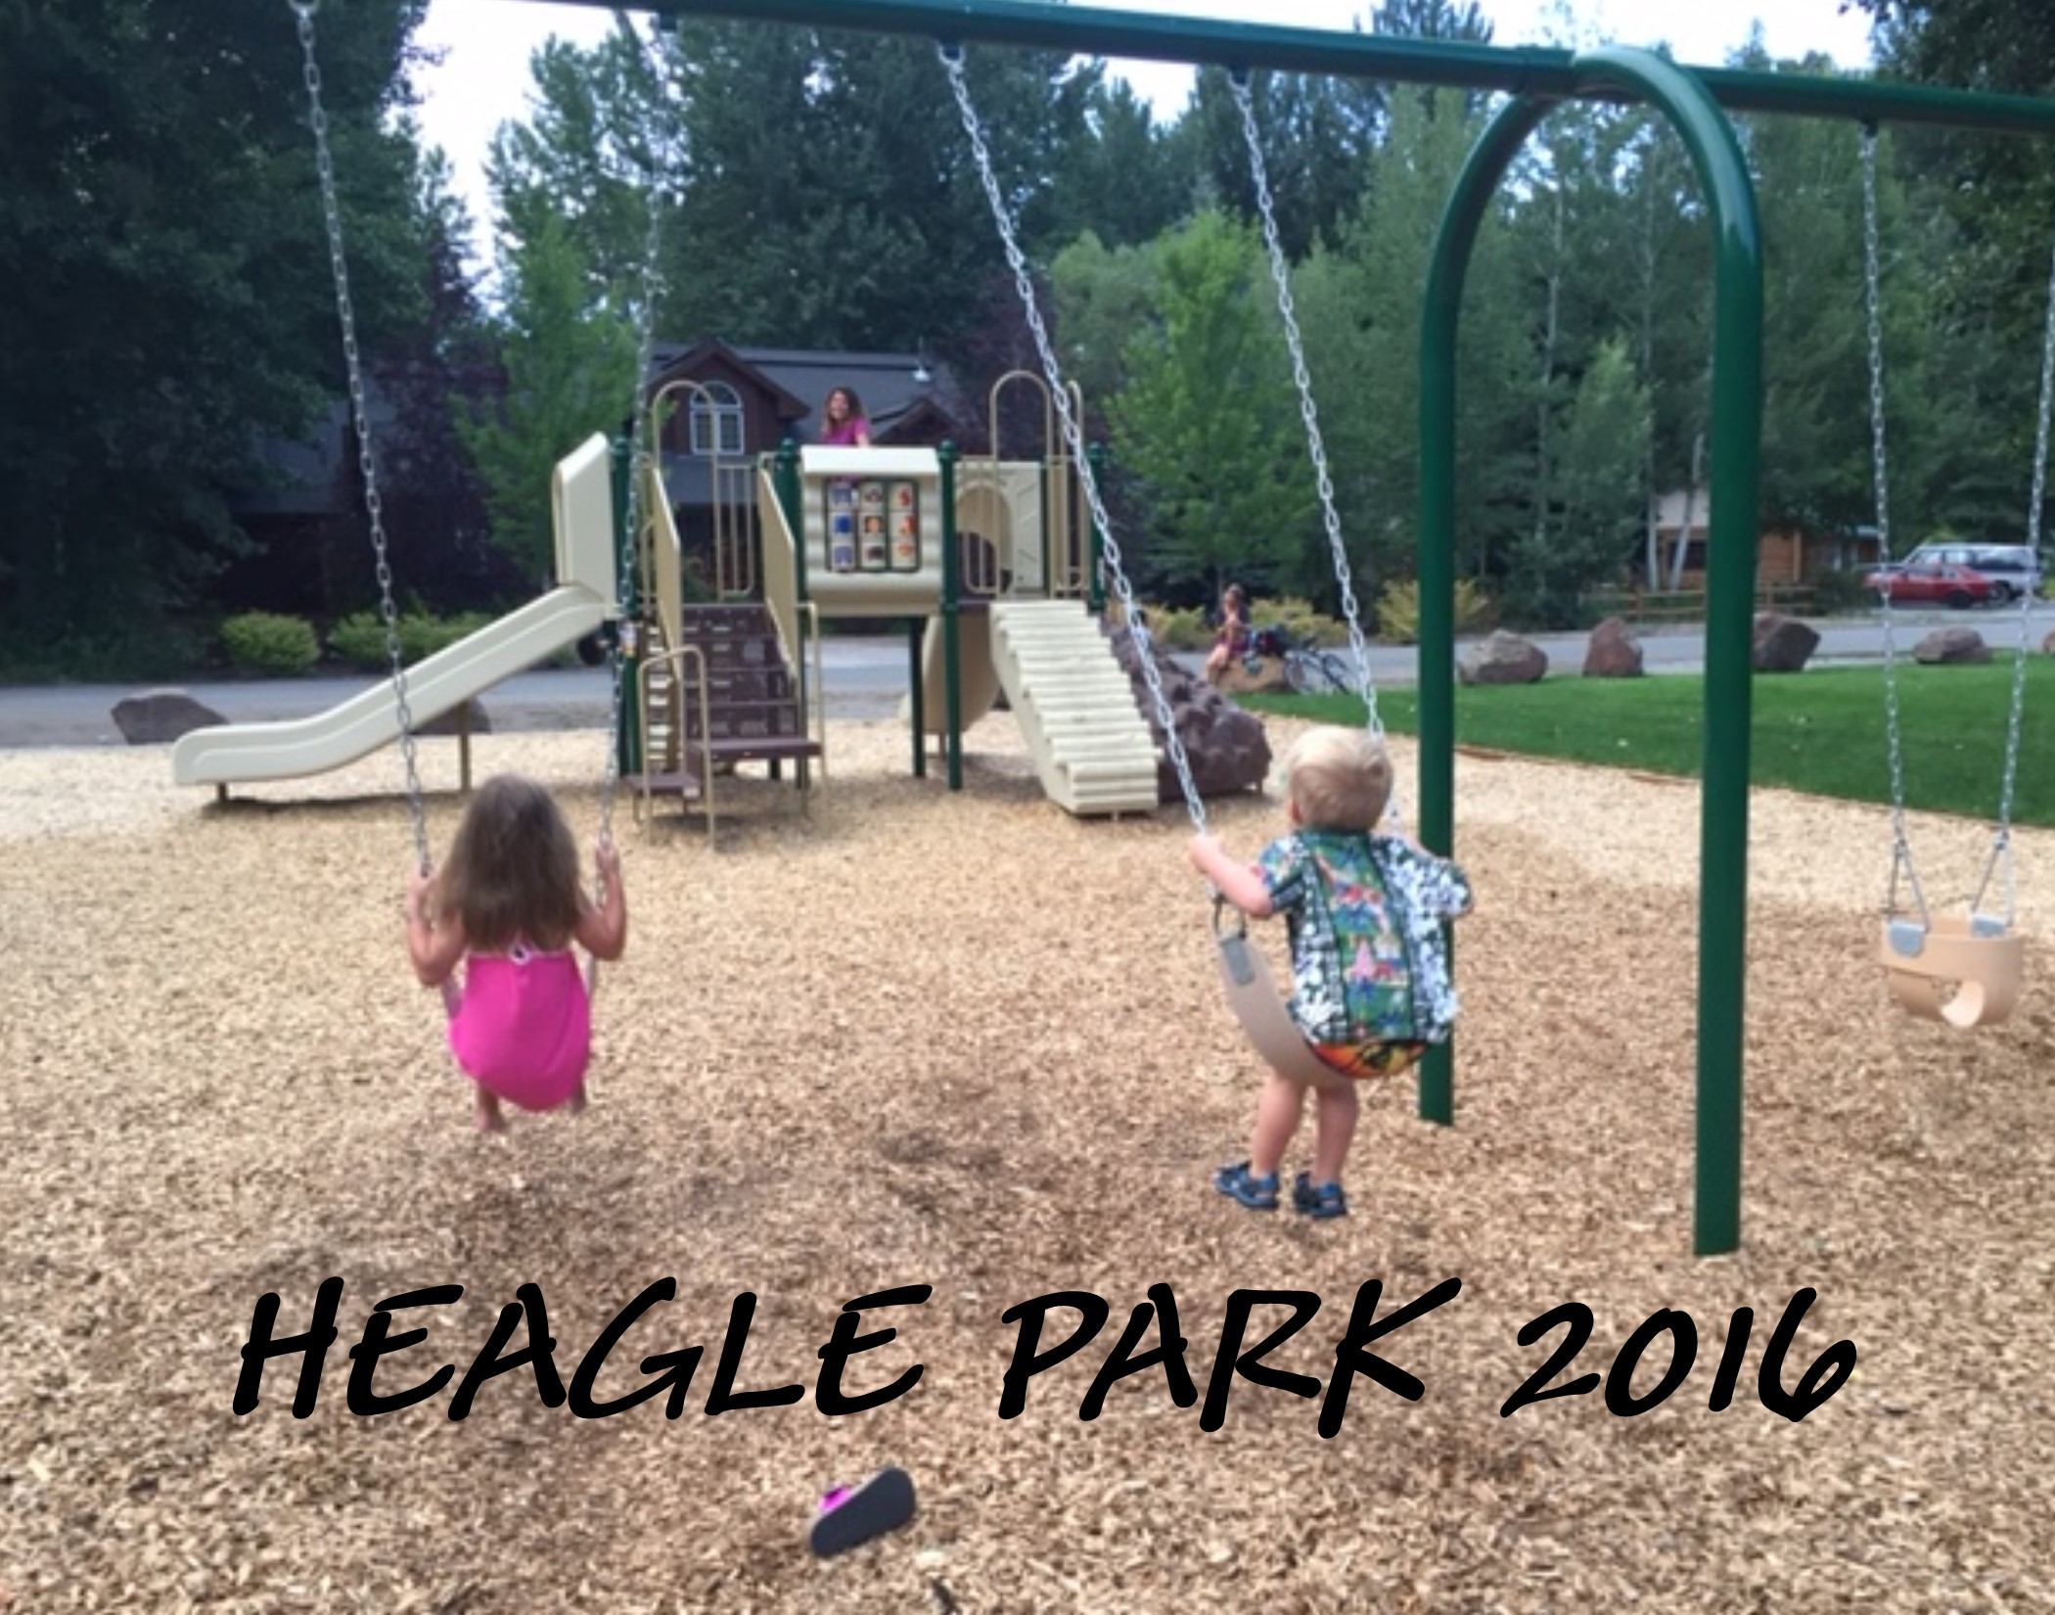

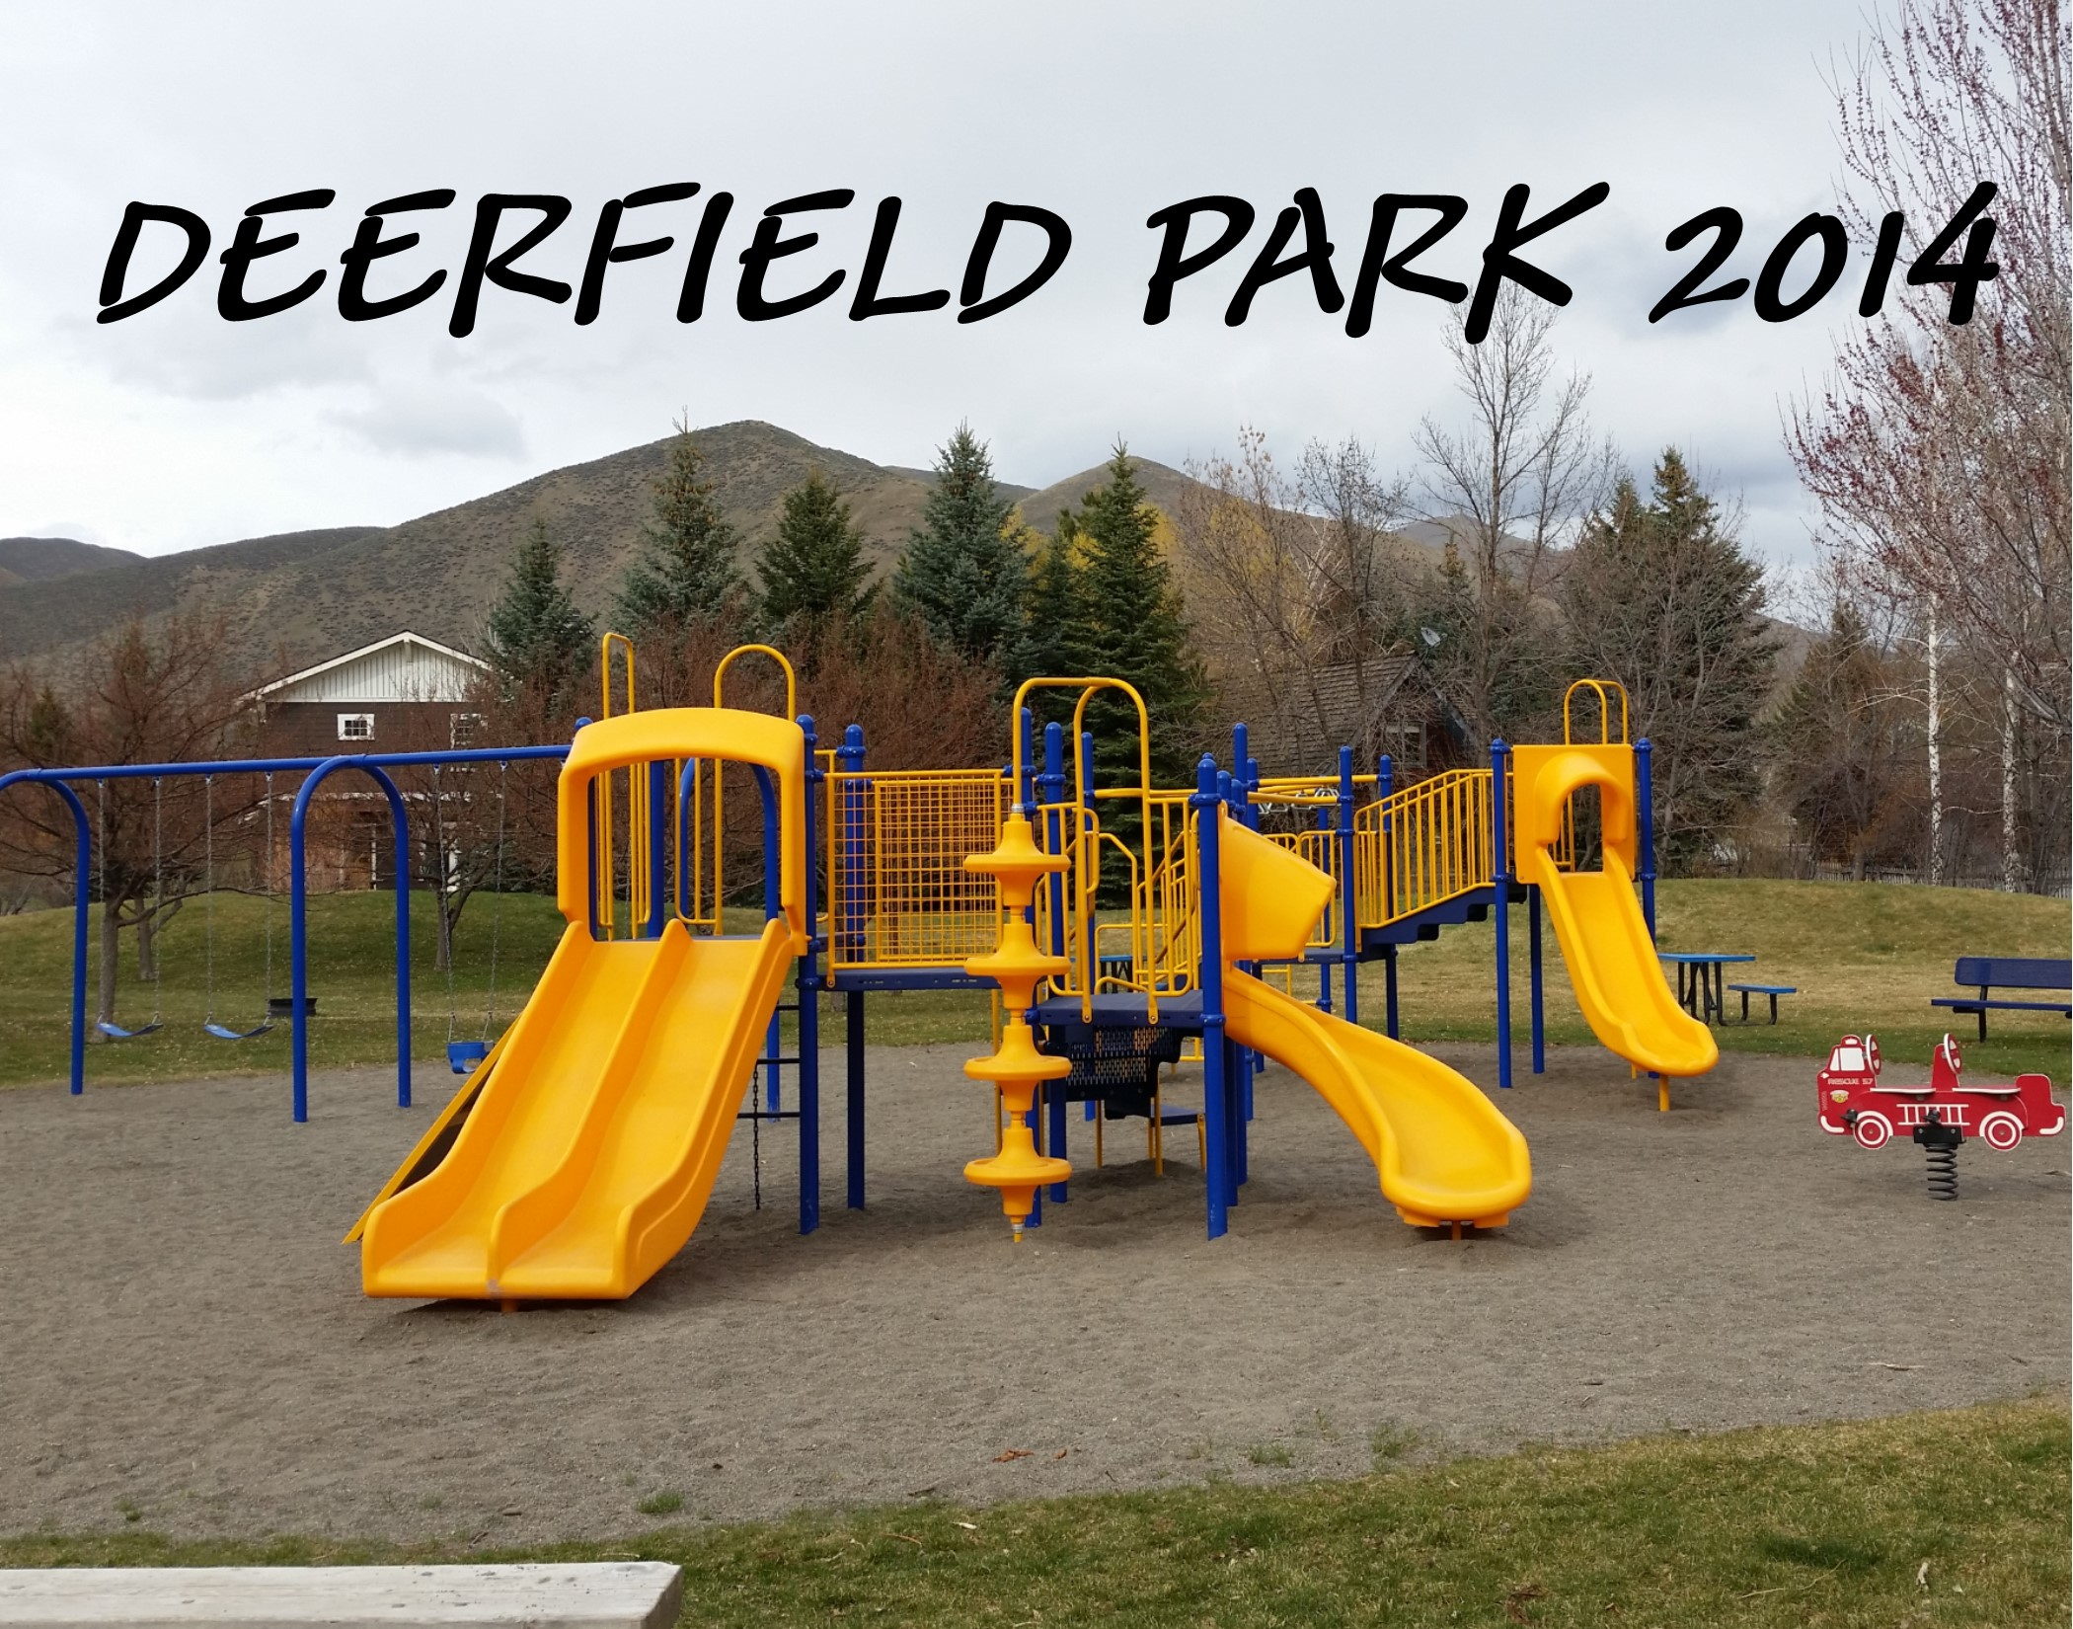

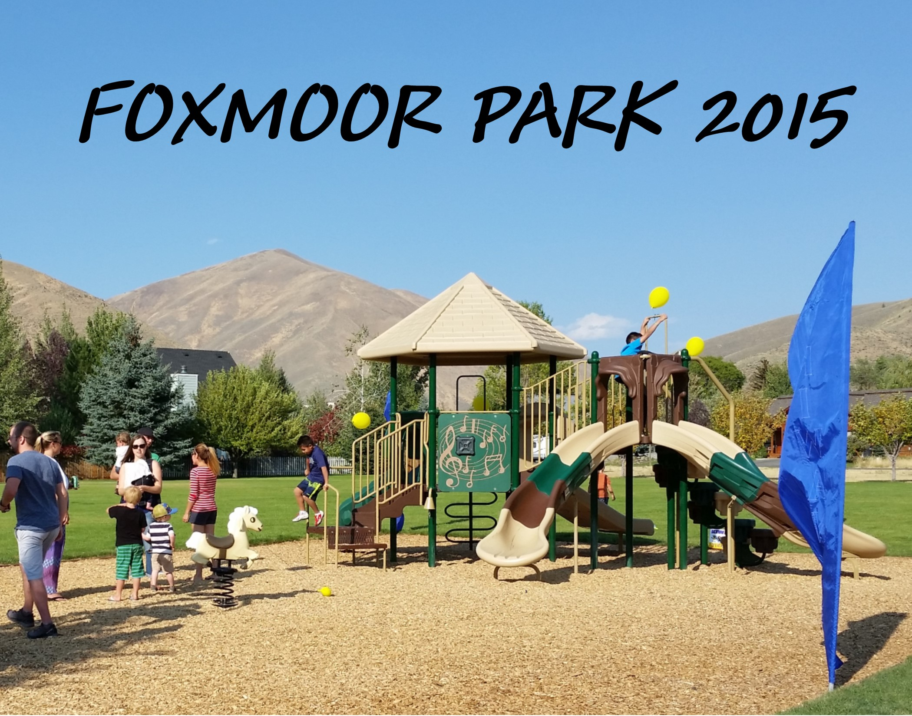

Past Projects

