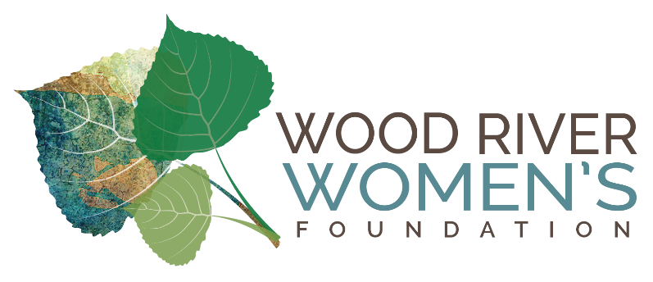
Wood River
Women's Foundation
Final Grantee Report
Due: As grant is completed or by June 20

Organization: Sun Valley Summer Symphony
Project Title: Instrument Bank Project Phase 2
Grant Amount: $19,840

1) Objectives & Outcomes (max. 200 words) –
The objective of the Instrument Bank Project Phase 2 was to allow us to purchase more instruments for students and add a support staff person to manage the Elementary Strings Program.
- We currently own 48 instruments and are in the process of negotiating with vendors to purchase an additional 8-10 in the sizes we determined this year to be most in need. We are confident we will now be able to offer an instrument to the majority of interested students which supports our goal of breaking down any stigma of students having a ‘loaner’ instrument versus being able to afford their “own” instrument.
- 67 students registered for the program and approximately 42 completed the program, about a 2/3 retention rate which is similar to last year.
- The demographic mix of students was roughly 45% Anglo and 55% Hispanic, which aligns with our goal of reaching students of all backgrounds.
- Due to the increased workload monitoring instruments and managing students, grant funds allowed us to hire an additional staff person. Stephanie Guzman joins our staff as Outreach and Developmental Programs Coordinator. Stephanie is a graduate of the SVSS School of Music as a violin and viola player, so can also help with teaching responsibilities.

2) Impact (max. 150 words) -
On the final day of the program, students shared what they learned with parents in an informal performance. Imagine 40 plus squirrely 9-10-year-olds all holding something that makes a lot of noise anxiously waiting to play! Imagine the surprise and delight on their parents’ faces, when what they played sounded really good! Nearly 100 parents attended, and they were amazed at the progress their students made. Our faculty commented that this was a particularly wonderful group of students, attentive and eager to learn. Due to lessons learned last year, we were able to better address the needs of such a large group. Student mentors from the high school, our instructors Ms. Sanders (cello) and Mr. Kremer and Ms. Guzman (violin/viola) expertly coordinated small and large group sessions that allowed students to go from just learning to hold the instrument to playing 8 short pieces of music for their parents. Several hope to continue playing and our Summer Strings program enrolled a record 18 students.

3) Photos (attached)
1. a view of just a portion of the instruments we have purchases in our storage room
2. Elementary strings mentors on their way to State Solo Competition. Wood River High School students who spent many weeks working with Elementary Strings Students. this is the only time I could get them all together as a group as they all worked different days with the elementary strings to be sure we always had at adequate support for the faculty.
3. a view of parents listening to their students perform.

I sent a few additional photos to Susan Flynt who used them in her impact team report, if you need more, let me know!

4) Budget (one table) –
Expenses | Amount requested from WRWCF | Actual Expenditures
Instrument Purchase | 15,000 | 15,000 *
Teaching Materials/books/strings | 1000 | Books: $465  Strings/Rosin: $ 425  Pencils, laminated cards: $50  Total: $940
Salary and Benefits | 3,840 | 3,906
TOTAL | 19,840 | 19,846
*$10, 595 of instrument budget has been spent to date, an assessment of specific needs regarding instrument type and size was made at the end of the program in late May so we could fill gaps in what we have, additional instruments using the remaining funds are being ordered this month.

