Organization Name: Blaine County Senior Council, dba The Senior Connection

Project Title: Available, Accessible and Affordable Transportation for Seniors: matching funds needed for an Idaho Transportation Department (ITD) grant
Amount of Grant: $25,000
Objectives and Outcomes: The WRWF grant provided the matching funds necessary to receive a grant from Idaho Transportation Department (ITD) allowing us to procure a new paratransit van. Our project objective was to improve the level of transportation service for Blaine County Seniors and increase overall ridership. We are pleased to report we are accomplishing both those objectives. Our goal was to increase ridership by 7% and we’ve already seen a 20% increase. With an 11-year old bus which is prone to mechanical issues, the para-transit van has been a critical addition to our rolling fleet of vehicles for two reasons. One, when the bus is in the shop for repair, we have an alternative mode of transport which we’ve never had in the past. Secondly, we are able to take both vehicles out on routes and excursions when capacity exceeds the use of just one vehicle.
Impact: The biggest impact this new van had was unplanned and unexpected. Being smaller than the bus, wheelchair riders instead of feeling “apart from”, feel “a part of” the community of riders. The suspension is so much smoother that it makes for a more comfortable ride on longer excursions. This is the van we’ll be taking to Shoshone Falls and Smiley Creek in the summer of 2018.
Photos:
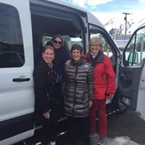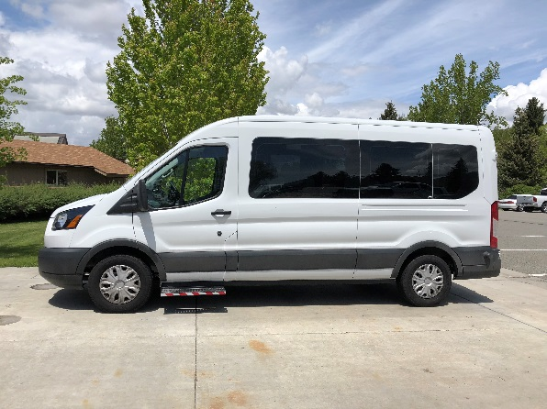
Budget: Our budget is straight forward. The monies from WRWF were used along with a $40,000 grant awarded from ITD for the purchase of a paratransit van.
Expenses | Amount Requested from WRWF | Actual Expenditures
capital funds | $ 25,000 | $ 25,000
TOTAL EXPENSES | $ 25,000 | $ 25,000

