Wood River Women’s Foundation – Final Grant Report
Organization: Rotarun Ski Area
Project Title: Snowmaking
Grant Amount: $10,000

Objectives and Outcomes:
Snowmaking at Rotarun ski area is an undertaking that incorporates a significant number of partners, government agencies, due diligence, and actionable steps. The dream for Rotarun snowmaking has long been in the vision of the community, and the Wood River Women’s Foundation grant is critical to creating the engineering to advance the vision into reality. Key points and objectives:

Enlist and employ local engineering firms to create the civil engineering required to:
- Vet and establish a new point of diversion for activation of current water right.
- Design a civil water work project to activate Rotarun’s current water rights from point of diversion to snowmaking pond.
- Create run off solutions for additional water as result of the system.
- Create construction quality plans that can be accurately bid on by contractors to design the system of delivery.

There were unexpected challenges that arose through the process of the original submission of the grant, to the current activation of the funds. Those challenges circled around timelines and a change of the point of diversion (aka water well). The engagement of the engineering firm to outline the project for a construction bid will dramatically improve our ability to advance the project.

Impact
Although difficult to quantify regarding engineering and affiliated planning, the need for a south valley ski venue is more pressing and urgent than ever. In a world where childhood obesity is rampant, and the income achievement gap is exacerbated, winter sport is our community’s response to keeping kids outside and active. The ability for Rotarun to implement a snowmaking system on its slopes will:
- Inspire the community to participate in a low cost/high return outdoor experience.
- Allow for secured and sustainable programming and outreach.
- Create an opportunity for economic development in the south valley as Rotarun realized its potential as a community hub and venue.

Thank you for your grant to Rotarun and its vision of snowmaking. The investment into our community is worthy of our time and best efforts.

Sincerely,

Craig Johnson, Vice- President Rotarun Ski Area Scott McGrew, Executive Director SVSEF
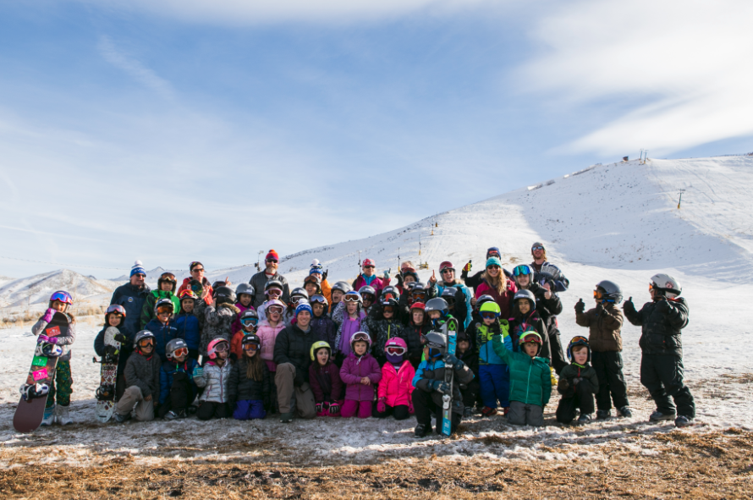

Picture of Rota rippers enjoying the splendors of winter. We had over 50 first generation kids introduced to the joy of skiing and snowboarding this past winter (despite a challenging snow year).

