Organization: Lava Lake institute for Science & Conservation

Project Title: Wood River Wolf Project (WRWP)

Grant Amount: $14,898.00

**1) Objectives & Outcomes**

**Objective 1.** Purchase and distribute nonlethal tools to most of herders in the Project Area and have at least one training session.

**Outcome:** Successfully deployed nonlethal tools to 75% of herders in Project Area and hosted a training workshop in eastern Oregon.

**Objective 2.** Conduct howl surveys in the early spring that would engage volunteers and provide a public education opportunity while gathering vital information on wolf populations.

**Outcome:** We conducted howl surveys on a regular basis from spring through fall, although no wolf responses were recorded.

**Objective 3.** Increase awareness and education about nonlethal deterrents in the local community and other states with wolf presence.

**Outcome:** Outreach/education events included: 7 presentations about coexistence, including a talk at the Ketchum library, 5 visits to Colorado, and one talk in Miami, Florida. WRWP also gave a Q & A session at the Sage School and hosted 2 wildlife trivia nights.

**Objective 4.** Recruit volunteers to assist with howl surveys, herder training and distribution of Band Kits, and provide additional human presence for sheep bands when wolves are in the area.

**Outcome:** Over the past year we recruited 15 volunteers to assist with project operations, including 8 Spanish/English translators.

**2) Impact**

In 2017 the Wood River Wolf Project extended its proven track record of preventing conflict between wolves and sheep by completing its second straight depredation-free season within the Project Area. Furthermore, WRWP’s success has gained worldwide recognition with an article about the project being published in “[International Wolf](http://www.wolf.org/wolf-info/wolf-magazine/winter-2017/)” magazine (see below) along with a publication in the *Journal of Mammology*, documenting the WRWP’s ability to reduce sheep losses to wolves using non-lethal tactics by 90% in the Project Area over the first seven years of the Project.

The Project’s model is also being looked at as an example by other states being recolonized by wolves, with input from Project members being mentioned in a Boulder Weekly article [here](http://www.boulderweekly.com/news/will-coloradans-free-wolves-states-public-lands/).

**3) Photos**

 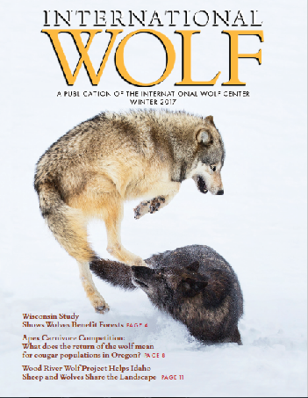



WRWP received a $12,000 grant from Patagonia which was used for immediate equipment purchases for the Project’s 2017 field season. WRWP also underwent a staff transition in 2017 which is why WRWF funds not used for equipment purchases were used to defray additional operating and training costs associated with extra time in the field required to get new Project members prepared.