Organization: The Hunger Coalition
Project: Bloom Youth Project
Grant Amount: $25,000

Objectives & Outcomes We’re thrilled to report that our eight Bloom Youth graduates met or exceeded each of the objectives defined in our original grant request thanks to your investment.
- The Hunger Coalition staff will facilitate a series of 16 life skills classes to all paid youth interns at the Bloom Community Farm site: Bloom Youth interns completed 16 life skills classes including budgeting, resume building, and interview practice.
- A minimum of one group meal will be planned, prepared and shared weekly for and by the interns over the course of the seasonal program: Bloom Youth interns planned, cooked, and shared at least one meal per week using ingredients they grew at Bloom Community Farm.
- 70% of paid youth interns will achieve their resiliency goal, which is individually crafted at the beginning of the season and completed over the course of their internship: 100% of our eight Bloom Youth graduates met at least one of their resiliency goals for the season.

In addition to these numbers, the individual stories of growth and resilience that sprung from this team of young people were remarkable.

Impact The stories of your impact run deep with every intern you supported last summer. Perhaps most notable is Diego’s story. He started the season skeptical and standoffish. After a summer of teamwork, farm work, customer service, and skill building, he grew into the program, poignantly citing gratitude as one of his strongest feelings by graduation. In a beautiful coming of age story, Diego joined us this summer as a Farm Assistant – a position with more responsibility and the opportunity to mentor upcoming Bloom Youth interns. He and his brother have built their own garden plot at their house in Picabo so they can grow fresh, healthy food at home. He has a second job at the movie theater in Hailey and has talked about pursuing a career in forensic pathology. His ambitions are possible thanks to your generous support.

Photos
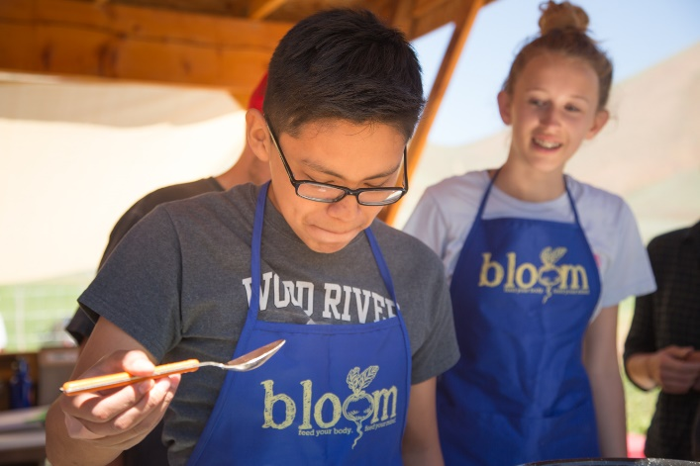
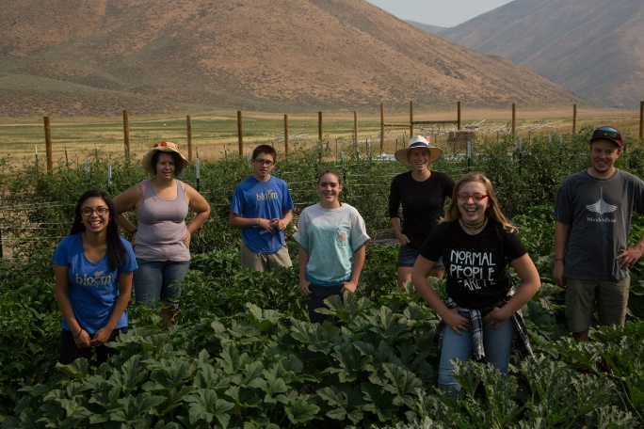

BYP Interns Peter and Maryanna enjoying a farm fresh meal
BYP Interns from L-R Tania, Matt, Diego, Ciera, Megan (Supervisor), Savannah, and Ned (Mentor)

Budget Actuals
Expenses | Amount Requested from WRWF | Actual Expenditures
Salary and Benefits | $ 1,403 | $ 35,884
Contract Services (paid intern salaries) | $ 20,697 | $ 20,754
Supplies | $ 800 | $ 1,806
Marketing | $ 500 | $ 1,025
Food (youth intern lunches) | $ 1,600 | $ 1,737
TOTAL | $ 25,000 | $ 61,206

