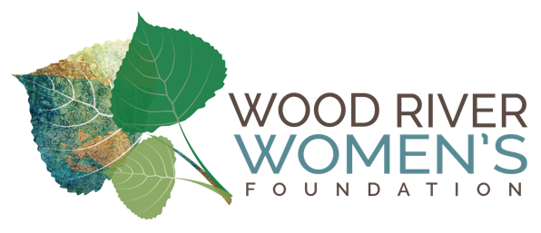
Wood River Women’s Foundation Final Report

Organization: The Advocates for Survivors of Domestic Violence and Sexual Assault
Project Title: Domestic Violence Housing First Program
Grant Amount: $25,000.00

1) Objectives & Outcomes
The Domestic Violence Housing First Program’s (DVHF) focus is on getting survivors of domestic violence and sexual assault into safe and stable housing as quickly as possible as well as maintaining existing safe housing. Our long-range goal is to increase survivor’s sense of safety and well-being while decreasing survivor’s program support needs from The Advocates’ as their lives become more stable.
Over the last twelve months The Advocates processed 108 DVHF requests for a total of $47,490. Ninety-two adults and 109 children benefited from DVHF flexible funding with allocations ranging from $35-$1,425, an average of $440.00. Most requests related directly to housing such as rent, deposits and/or utilities. Forty of those adults and 56 of those children directly benefitted from the Wood River Women’s Fondation generous grant.

Measurable program objectives:
 | PROGRAM OBJECTIVE | OUTCOME FOR WRWF $25,000 | OUTCOME DVHF PROGRAM TO DATE
1 | Compared to intake/program entry, program participant needs will lesson following housing stability | 94% reported their needs lessoned following housing stability | 98% reported their needs lessoned following housing stability
2 | At least 80% of program participants will report an increase in their overall sense of well-being | 92% reported an increase in their overall sense of well-being | 94% reported an increase in their overall sense of well-being
3 | At least 80% of program participants will report an increase in their sense of safety | 97% reported an increase in their sense of safety | 93% reported an increase in their sense of safety
4 | We expect at least 140 people to benefit from the program. Approximately 40 adults and 60 children will use the transitional housing, flexible funding and/or matched saving account of DVHF. Housing related case management will assist at least 75 adults and 25 children indirectly via assistance provided to their mother. | One hundred and fifty-seven adults and 159 children benefited from the DVHF Program: 40 adults and 56 children received DVHF flexible funds; 9 women and 14 children utilized our transitional housing; 10 clients opened matched savings accounts and 101 adults and 99 children from housing related case management. | Two-hundred and thirteen adults and 173 children benefited from the DVHF Program: 92 adults and 109 children received DVHF flexible founding; 10 women and 16 children were/are in transitional housing; 24 adults opened new matched saving accounts and 157 adults and 113 children from housing related case management.

2) Impact:
The WRWF’s $25,000 grant for the DVHF program allowed 17 adults and 20 children to leave abusive, unsafe relationships and 23 adults and 36 children to remain in safe, stable housing. The impact of the grant and DVHF Program was so profound that The Advocates raised additional monies to continue to provide flexible financial support which has helped an additional 12 adults and 18 children leave abusive relationships and 40 adults and 35 children to remain in safe, stable housing. Some DVHF funds were used to help a fully employed, young, single mother who came to The Advocates for help with a Civil Protection Order (CPO). We assisted her with filling out the necessary paperwork, helped her deecalate and offered guidance with safety planning for her and her son. However, within a few weeks her ex- boyfriend destroyed all of her belongings and her home. The largest allocation of $1,425.00 was for a housing deposit that enabled her and her son to get back into a safe home.

3) Photos – We do not have any photos to share due to client confidentiality.

4) Budget:

Domestic Violence Housing First WRWF Budget Report

Expenses | Amount requested from WRWF | Actual Expenditures
Salary and Benefits | 0 | 0
Occupancy | 0 | 0
Flexible Financial Assistance | 20,000 | 20.000
Matched Savings Accounts | 5,000 | 5,000
TOTAL | 25,000 | 25,000

WRWF funds were used 100% per the grant agreement.

.

