Wood River Women's Foundation Final Grantee Report

Organization: Girls on the Run of the Wood River Valley
Project Title: Volunteer Coach Training & Support Initiatives
Grant Amount: $8,200

Objectives & Outcomes
- Create a team of 24-32 of inspired volunteers
  - Cara Liberator was hired as a T3 Coach Trainor and Program Coordinator. She receive our Nationally offered T3 training.
  - Cara assisted in leading an all coach training in the Fall of 2017 and Spring 2018 seasons.
  - 43 coaches served during the fall 2017 and spring 2018 seasons of the program. 10 of which were part of our pilot sites this past spring in Twin Falls and Fairfield.
  - Excluding the new sites, of the sites we normally serve 50% were returning coaches from previous seasons.
  - 89% of the entire coaching staff received our T3 Training
  - All sites were visited at least twice a season by Cara as a Program Coordinator, and more if assistance was needed.
- GOTRWRV will strive to make statistically meaningful improvements for participants on the 5C’s + 1 and physical activity indicators.
  - 188 girls were served during our two seasons. This is an increase of 57% of our anticipated participation.
  - During the Spring 2018 season a pre- and post-season survey was conducted of participant’s level of improvements for participants on the 5C’s +1 and physical activity indicators. Result showed a statistically significant improvement in these areas.
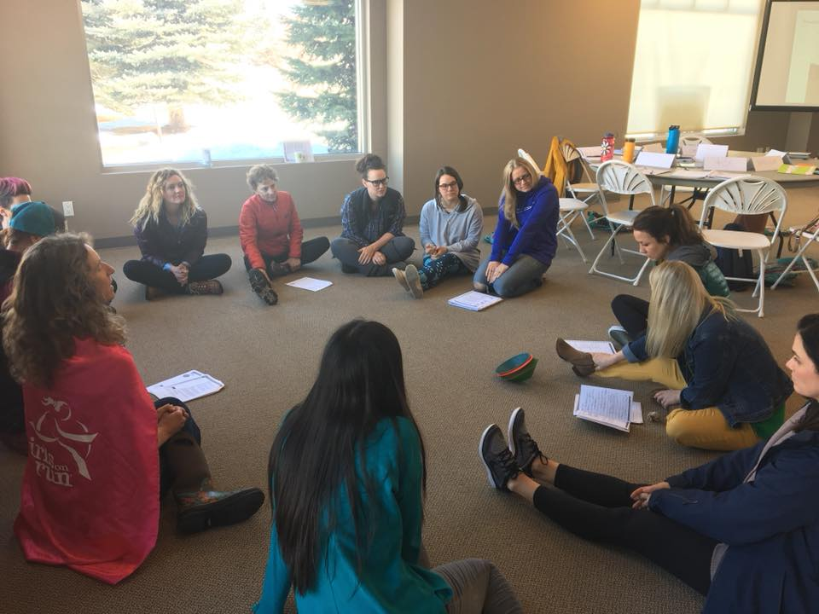
Impact – ​Our volunteer coaches are the key to the success of bringing the program alive for our participants. Having a new staff person solely dedicated to training, as well as quality control of program implementation, allowed for coaches to bond with the participants and work together as a team to guide them through the experience. One parent shared this about her daughter’s experience:
“We noticed an improvement in our daughter’s peer-to-peer relationships, confidence at school, self-satisfaction, and physical abilities/habits. It really challenges her physically. We trained as a family on the weekends to prepare for the 5k and that helped her do better at the race.”
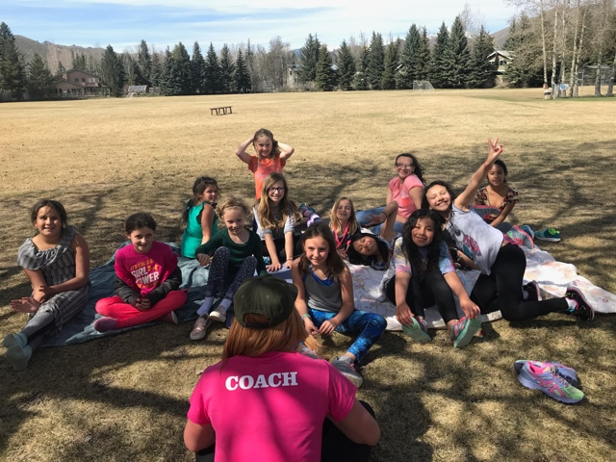
Budget
Expenses | Amt Requested | Actual
Salary* | 3843 | 3581
Contracted services | 680 | 680
Occupancy | 402 | 402
Training/Travel | 1243 | 1243
Insurance | 60 | 60
Equipment/Supplies* | 418 | 1098
Printing/Postage | 128 | 128
Licensing | 424 | 424
Marketing | 340 | 340
Background checks | 34 | 34
Volunteer appreciation | 340 | 340
Admin | 288 | 288
*Cara spent less hours than planned to complete program coordination job duties. Amount was shifted into additional curriculum supplies.

