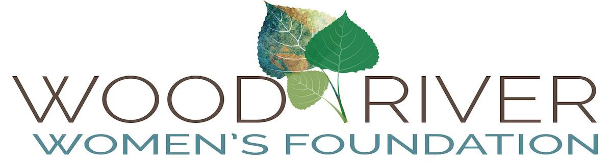

Grant Agreement for 2019

Grantee:

Address:

Contact Person:

Email: Telephone:

Grant Amount:

Grant Purpose:

________________________________________________________________________

Expending of Funds
This grant is to be used for the purpose described in the grant proposal and in accordance with its budget as outlined in the proposal. The term of the grant shall be July 1, 2019 through June 30, 2020. Prior to the distribution of funds and throughout the term of the grant, the grantee organization shall notify the Wood River Women’s Foundation, Grants Coordinating Committee Chair, if any circumstance changes that would affect the grantee’s ability to carry out the project, such as organizational leadership, financial status or key program personnel. The funded project is subject to modification only with the WRWF’s prior written approval. The grantee organization is responsible for the expenditure of funds and for maintaining adequate support records.

The grantee shall return any unexpended funds to WRWF:
- At the end of the grant period and at the discretion of the WRWF
- At any time after the award of the grant and throughout the term of the grant, if WRWF determines that the grantee has not performed in accordance with this agreement and approved program budget
- If the grantee loses its 501 (c)(3) tax exempt status

Payment Schedule
Grants will be awarded in July 2019 after Idaho Community Foundation receives a signed copy of this Grant Agreement from WRWF. Funds are distributed electronically directly from ICF to your organization.

Impact Team
Grantee will be assigned an Impact Team at the outset of the grant year in July. The Impact Team member(s) will meet with you and explain our Impact reporting process. Final Impact reports will be due upon completion of the project or no later than June 22, 2020.

Public Announcements
Wood River Women’s Foundation (WRWF) will be named as a source of funding in any announcements of the grant award made by the grantee; for example, public service announcements, news releases, listing in an annual report, or in publication or information concerning the grant or the program. The formal attribution is: Wood River Women’s Foundation, a Philanthropic Gift Fund of the Idaho Community Foundation. Please include copies of any such announcements in your end-of-grant report.

WRWF welcomes the use of its logo in recognition of its support of your organization. Please contact the Grants Coordinating Committee for full particulars at wrwfgrants@gmail.com.

________________________________________________________________________

The terms of this contract are accepted by:

____________________________ _______________________
Authorized Signature Date

Name & Title________________________________________________________

A signed copy of this agreement must be returned to the Wood River Women’s Foundation before funds can be distributed. Please retain a copy for your records.

Email is preferred. Please scan the signed agreement and send in pdf format to:
Grants Coordinating Committee at wrwfgrants@gmail.com

If returning by US Postal Service, please mail to:
WRWF Grants Coordinating Committee
Attn: Grants Chair
P.O.Box 3686
Ketchum, Idaho 83340

